Installation Guidelines

Lighting

ATNG71L Illuminated Aluminium Channel

Equipment Required

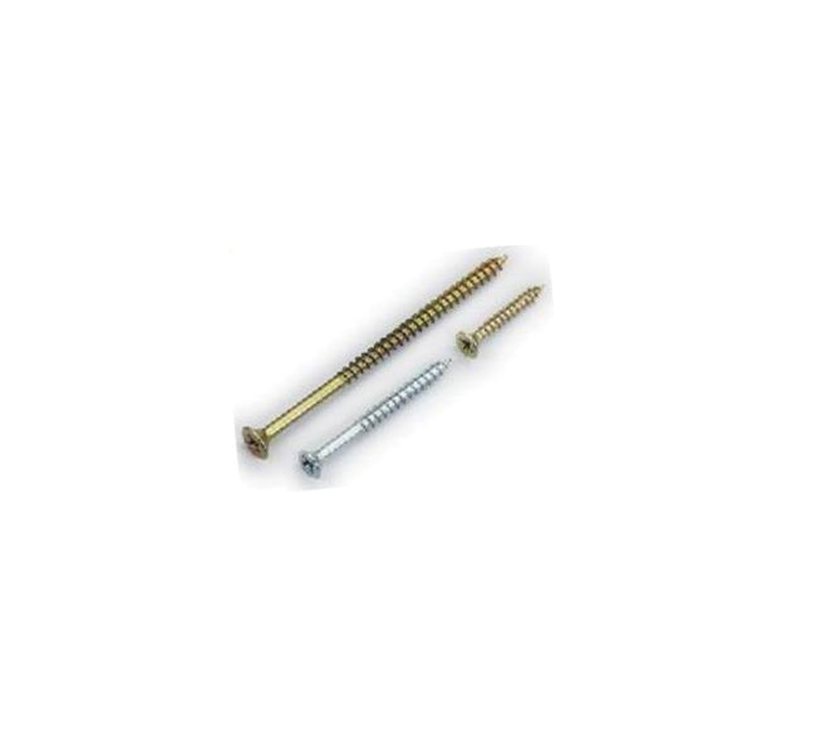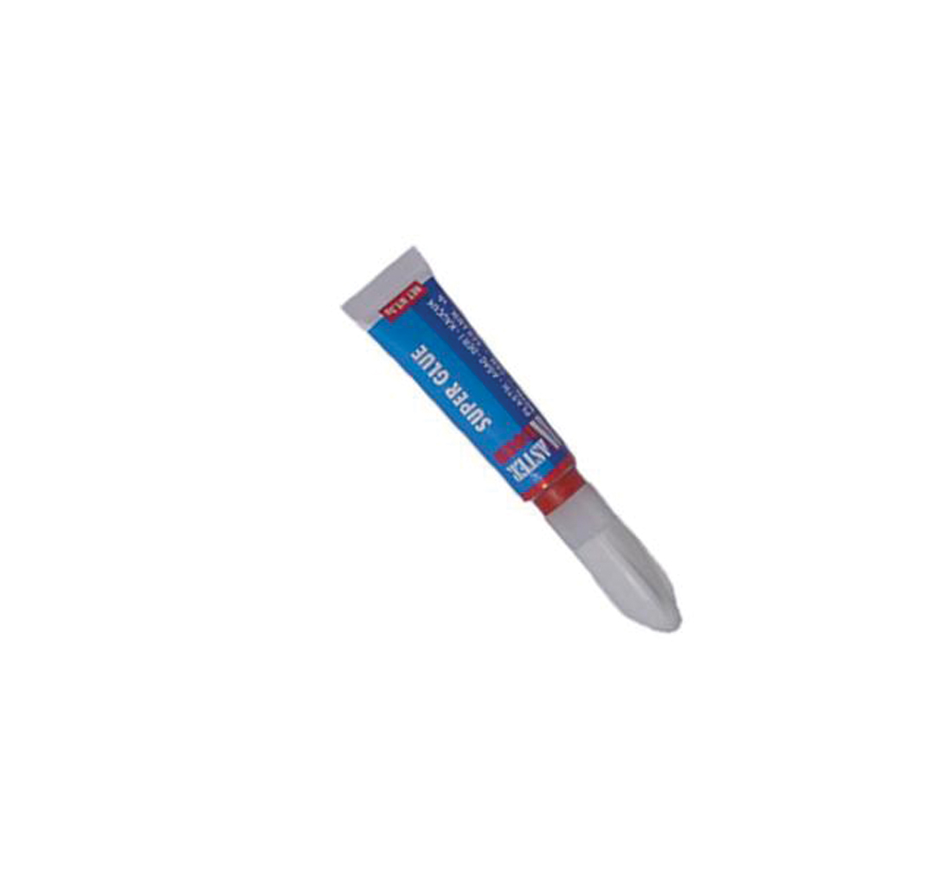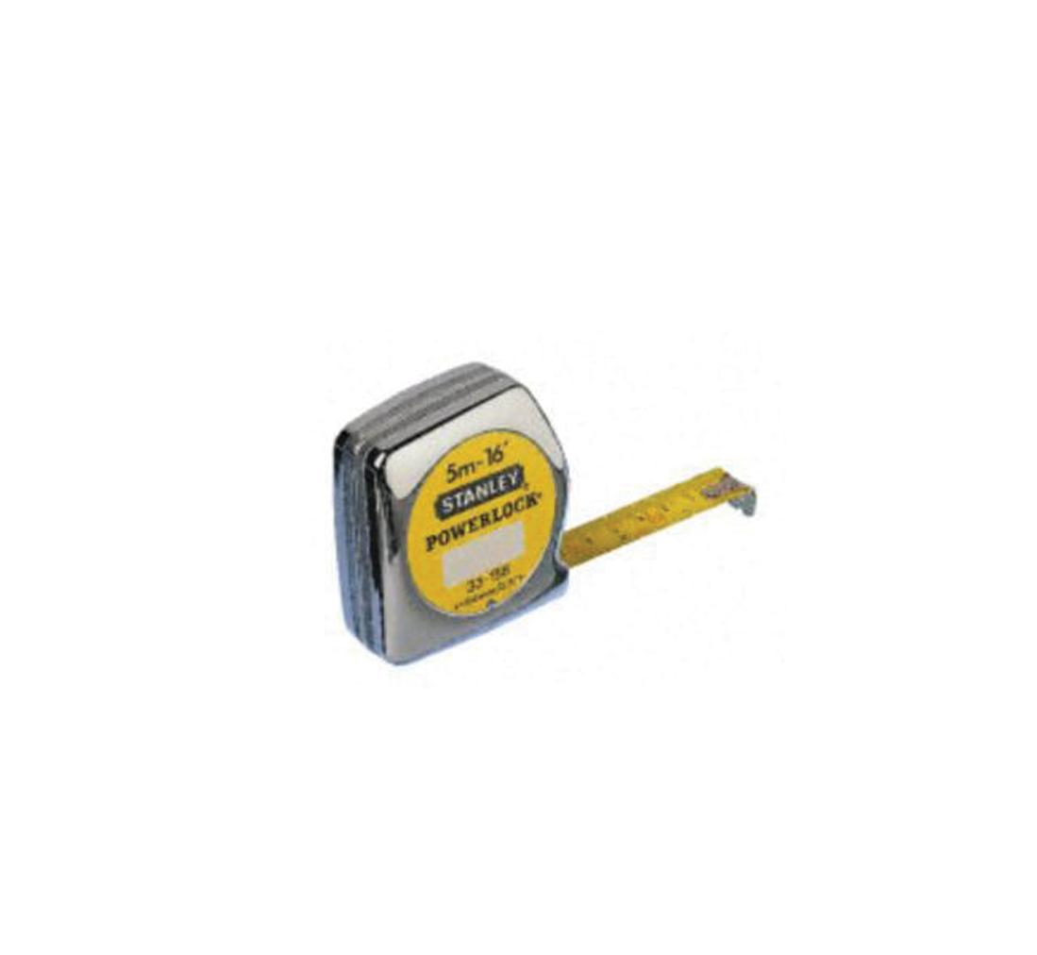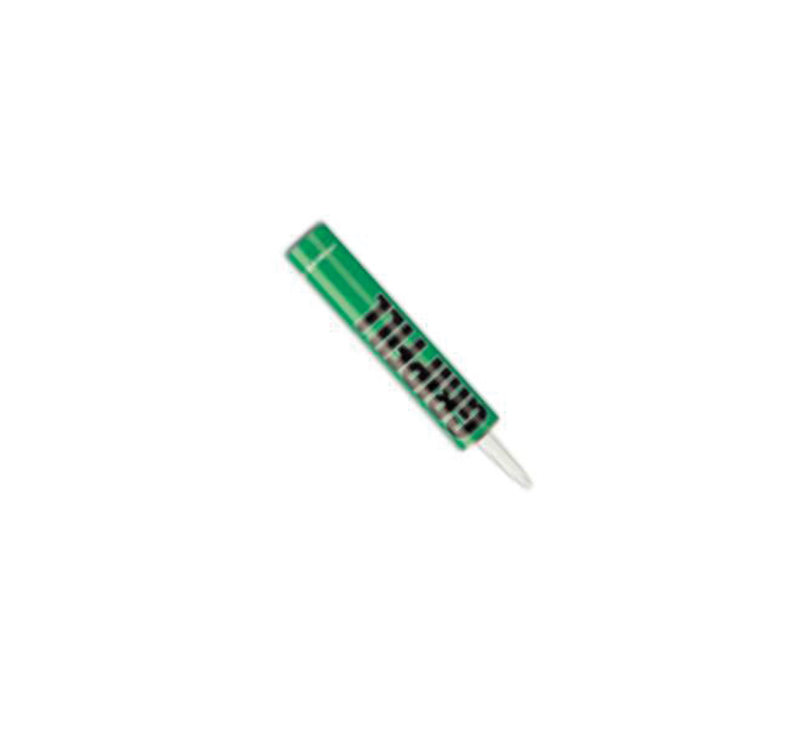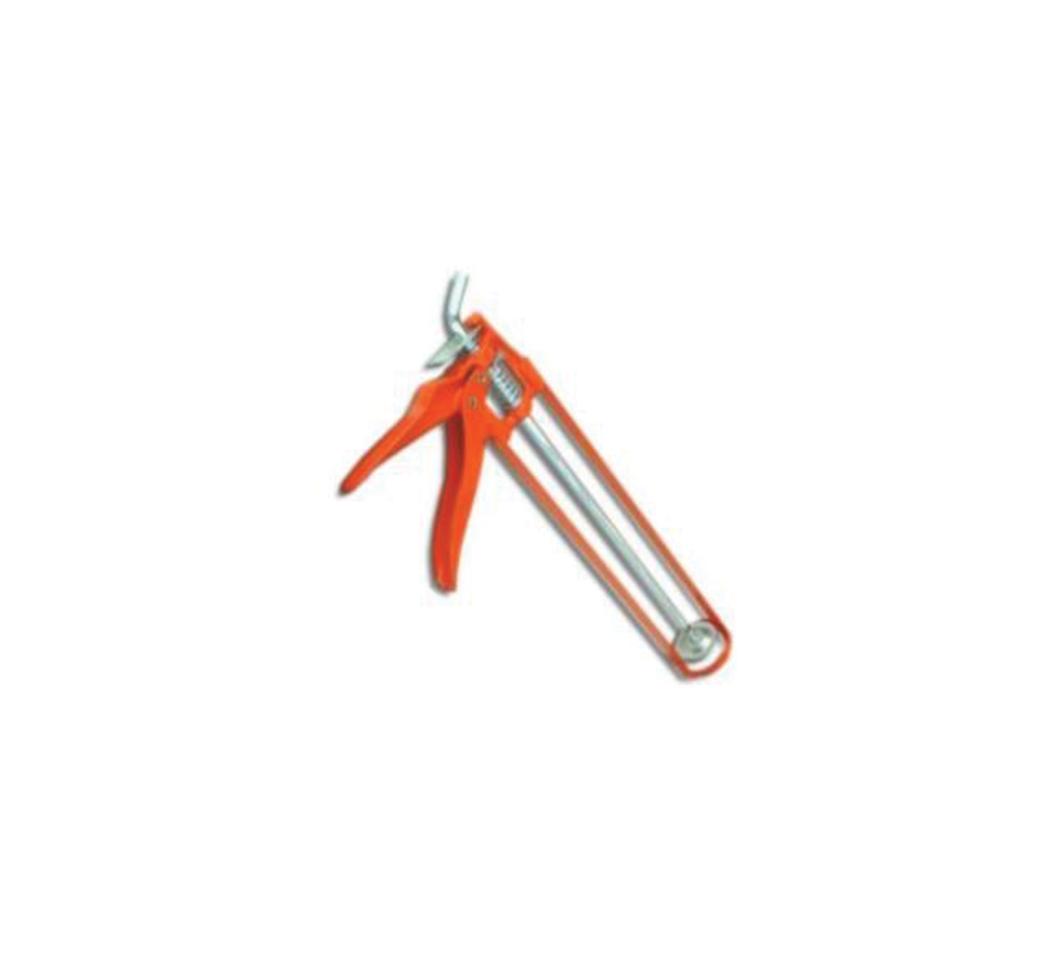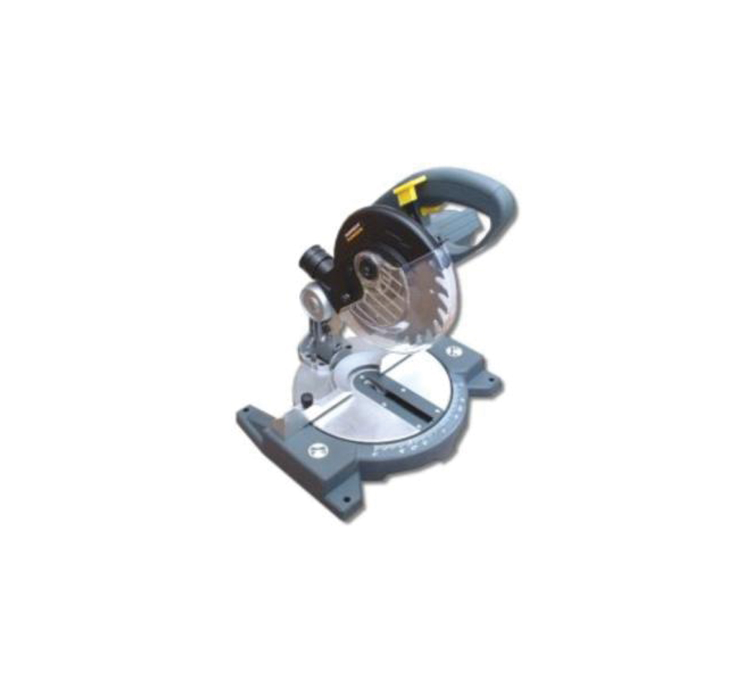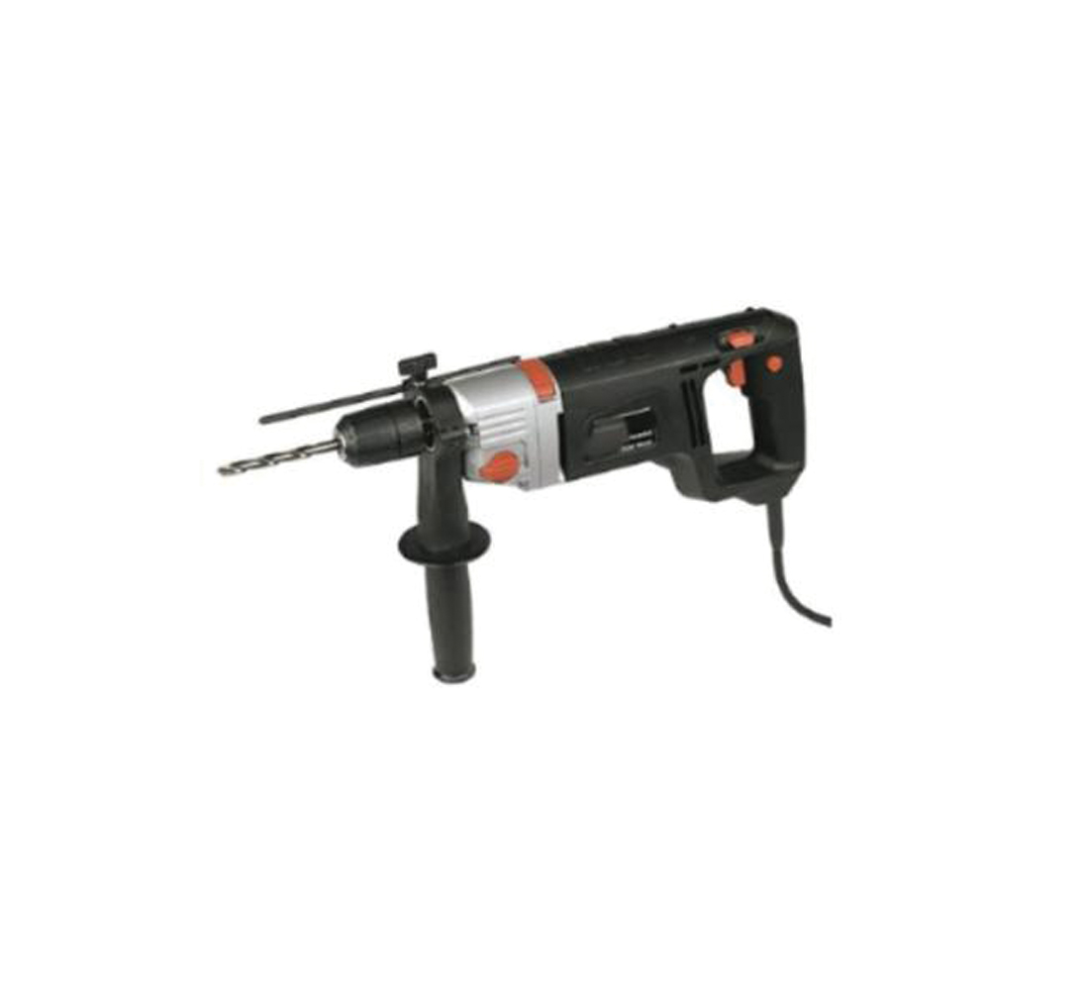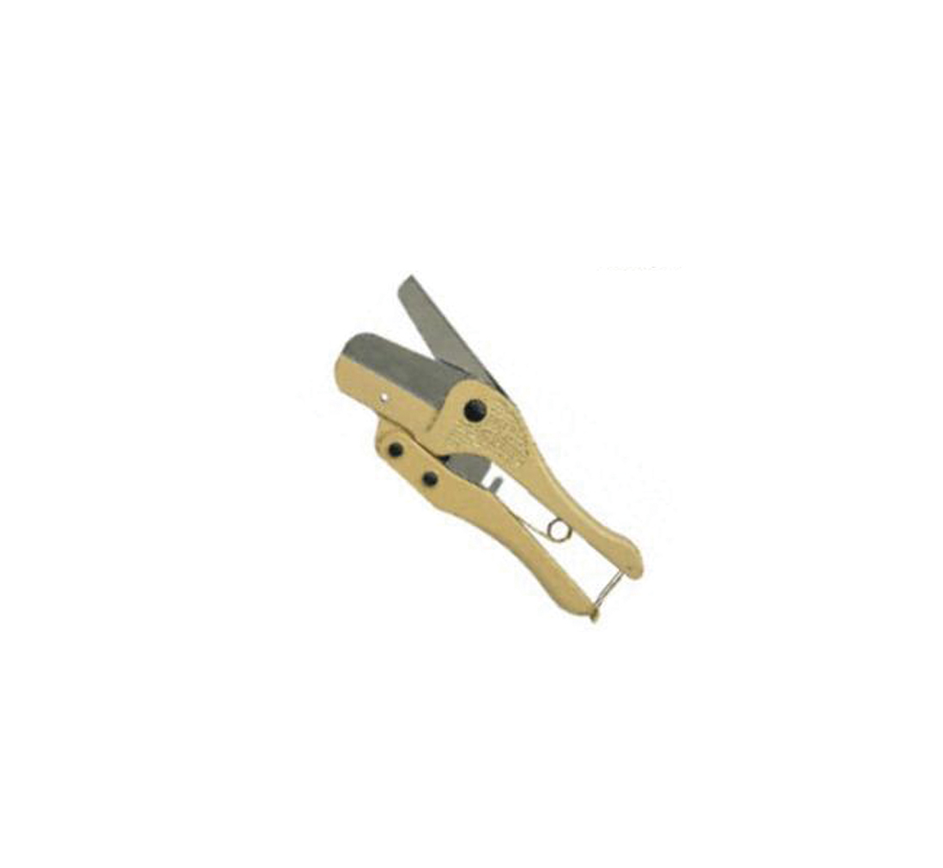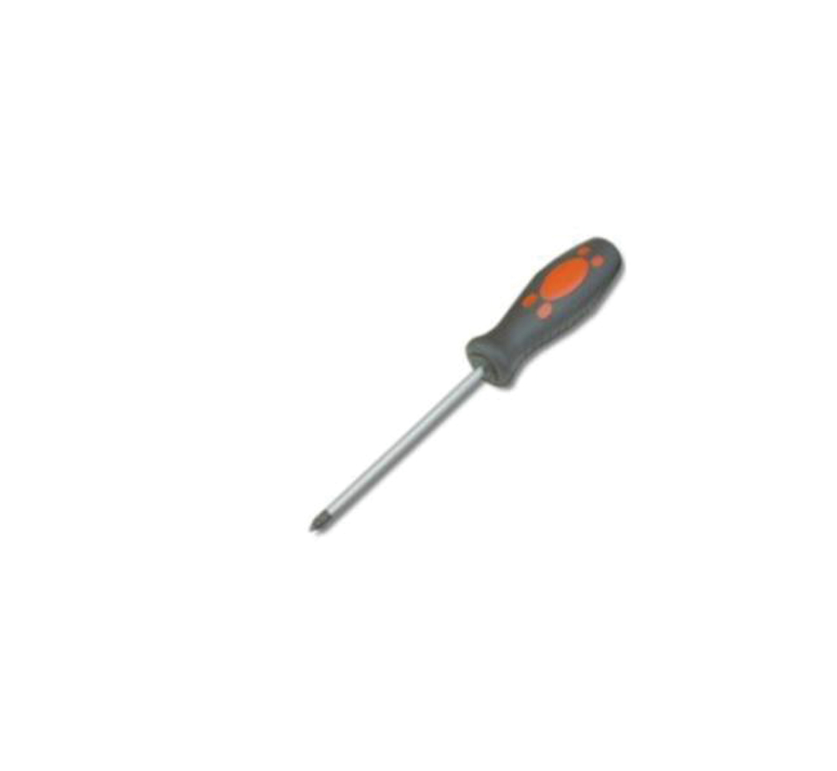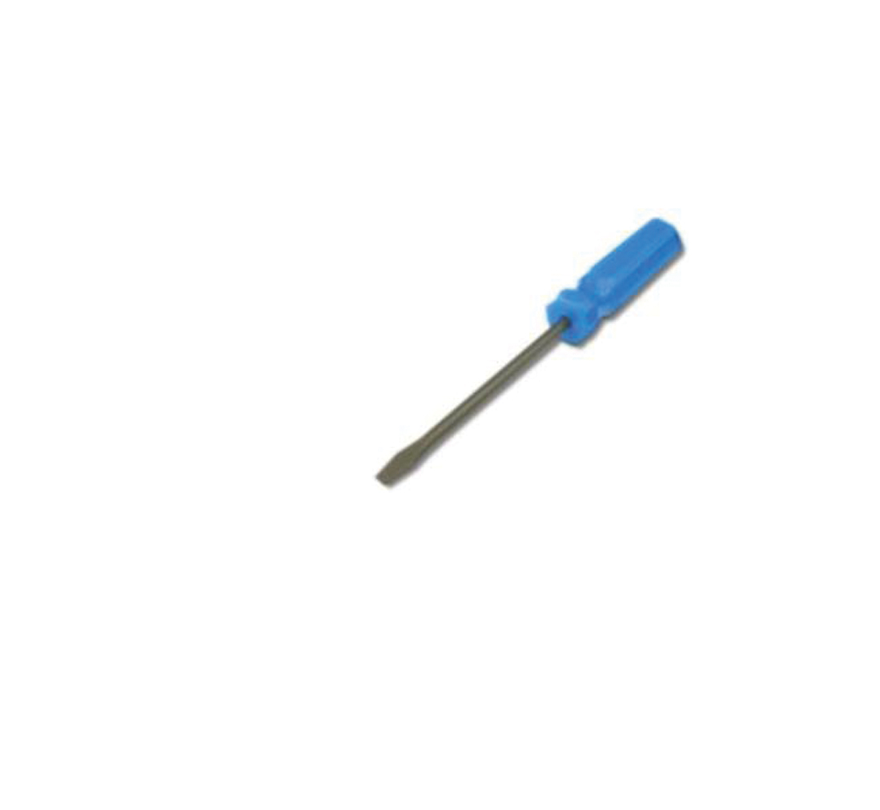

When materials are supplied, the Gradus marked packaging clearly states the product code contained within.
The power supplies are clearly marked with the input and output voltage ranges, frequency and power rating.

NB: A qualified electrician must install the power supply unit, and run cable to the junction box for the connection of the lighting.

Planning

- From the plan / drawing, calculate the number and length of steps to be illuminated.

- Take templates of any curved stair edging that is required

- Calculate your electrical requirements:
IAV/600/6 strip = 0.25A / 3W per metre
Continuity = 0.025A per LEDASSY

  - Circuit loading should not exceed rating of P.S.U.

  - The loading must calculated, and divided between the power supplies evenly.

  - The Power Supply units must be Class 2, 12VDC, correctly rated for the applied load.

- It is recommended that every circuit on the secondary side of the power supply is fitted with a quick blow type fuse. The rating of this fuse must be calculated to be as close as possible to the nominal current rating of the circuit.
The circuit current can be calculated from the figures given above, or preferably, taken from a site measurement with a suitable ammeter.

The number of feed points will depend on the quantity of power supplies, the location of the lighting and the volt drop of any circuit.

From the volt drop calculations, ensure if the voltage is dropping below 9V, then the lighting is refreshed from another feed point.

Voltage Drop = 65mV / A / M

Adhesives, Sealants and Crimps

- Where references are made to adhesives for fitting stair edgings, this should be a high performance gap filling adhesive.
- Superglue is used to hold the end caps to the stair edgings, and this should be of the cyanoacrylate type.
- Silicone sealant refers to acetoxy, silicone rubber compound equivalent to 732 RTV.
- Crimps should be the butt splice type, UL approved and suitable for 14AWG cable.


Data Sheet: (sheet 1 of 2) 18.04.11
Gradus Accessories, Park Green, Macclesfield, Cheshire SK11 7LZ England UK Tel: 01625 428922 Fax: 01625 433949
www.gradusworld.com

Mitre Saw

Power Hammer Drill

Tape Measure

Mastic Gun

Gap Filling Adhesive

Super Glue

PVC Conduit Cutter

Selection of Pozidrive and Slotted Screwdrivers

Suitable Screws

Installation Guidelines

Lighting

ATNG71L Illuminated Aluminium Channel

Aluminium Profiles

Light can only project in one direction from aluminium profiles so ensure that the LEDs are pointing away from the profile and the black stripe on the LR1238 tube is not blocking the light.

Installation of the Step System

- It should be ensured that all surfaces to which the profile is to be fixed are dry, flat and free from any contaminants.

- Mark the position of the end caps on the step to determine the length of profile and backplate required.

- Cut the profile and backplate to the size required.

- Place the profile in position and mark the position of the screw holes onto the substrate.

- Drill the substrate to a depth of 30 - 35mm and insert suitable fixing plugs into the holes.

- Apply high performance cartridge adhesive with gap filling properties (e.g. Gripfill) to the back of the profile and place onto the substrate. Ensure that all of the profile is in contact with the substrate and there is a minimum 80% coverage of adhesive on the underside of the profile. Please refer to adhesive manufacturers data sheets for application details.

- Using 6mm or 8mm screws (dependent on profile) fix through the profile, into the plugs and tighten.

- Apply silicone into the channel to help secure the LR1238 tube.

- Insert either the Interlok Advance or Continuity lighting system into the LR1238 tube.

- If using Interlok Advance - fill each end of the LR1238 tube with silicone to prevent liquid ingress
- If using Continuity – insert with both LED housings connected to the rod and tube at either end

For further information on installing the lighting systems, refer to Interlok Advance or Continuity installation instructions.

- Insert the LR1238 tube into the stair edging channel.

- Use through crimp connectors to connect the LED/ASSY or IAVC1 wires to the supply cables. Continue this procedure for each step.

- Apply super glue adhesive to the legs of the end cap and fix it into the end of the stair edging.

Note.

The profile should be installed directly onto the substrate and NOT on top of any floorcovering. The floorcovering should be abutted up to the back edge of the profile.

If any further information is required, please do not hesitate to contact Gradus Technical Services on (+44)1625 428922 or fax on (+44)1625 425226

Data Sheet: (sheet 2 of 2) 18.04.11
Gradus Accessories, Park Green, Macclesfield, Cheshire SK11 7LZ England UK Tel: 01625 428922 Fax: 01625 433949
www.gradusworld.com

